AgroGPT: Efficient Agricultural Vision-Language Model with Expert Tuning

1st T. Vijaynag  Computer Science and Engineering  Keshav Memorial College of Engineering  Hyderabad, India  tvijaynag@gmail.com | 2nd Srinija Burugadda  Computer Science and Engineering  Keshav Memorial College of Engineering  Hyderabad, India  bsrinija1@gmail.com | 3rd Parthiv Kumar Kelam  Computer Science and Engineering  Keshav Memorial College of Engineering  Hyderabad, India  parthivofficial08@gmail.com
4th Rakshitha Jilkapally  Computer Science and Engineering  Keshav Memorial College of Engineering  Hyderabad, India  rakshithareddyjilkapally26@gmail.com | 5th Bucchireddy Nandini  Computer Science and Engineering  Keshav Memorial College of Engineering  Hyderabad, India  nandinibucchireddy@gmail.com | 6th Manchoju Pravallika  Computer Science and Engineering  Keshav Memorial College of Engineering  Hyderabad, India  pravallikamanchoju@gmail.com

Abstract —
Agriculture is increasingly embracing Artificial Intelligence (AI) and multimodal learning systems to enhance decision-making, precision, and productivity. This paper presents AgroGPT, an efficient Vision-Language Model (VLM) fine-tuned for agricultural applications. By integrating image-based features with large language models, AgroGPT generates domain-specific insights,enabling farmers and researchers to diagnose plant diseases, identify pests, and recommend sustainable solutions. The model leverages the Graph-based expert tuning pipeline to
enhance visual understanding and conversational depth. Through AgroEvals, a custom evaluation benchmark. AgroGPT demonstrates superior
accuray in recognizing fine-grained agricultural concepts compared to general-purpose models. This work highlights AgroGPT’s role in promoting AI-driven precision agriculture, enabling intelligent
analysis and guidance through multimodal conversational capabilities.

Keywords –
Index Terms— Agriculture, Artificial Intelligence, Vision-Language Model, Crop prediction, AgroGPT, Precision farming.

I .INTRODUCTION

Agriculture is one of the most important sectors that supports the global economy and provides food for the growing population. With the increase in technology, Artificial Intelligence (AI) is now being used to help farmers make better and faster
decisions. Many AI-based models have been developed to detect crop diseases, predict yield, and improve farming methods.
AgroGPT is a smart AI model that combines both image and language understanding to help in modern farming. It can analyze crop images, identify plant diseases, detect insects, and suggest suitable solutions. AgroGPT is trained using agricultural datasets that include plant diseases, fruits, weeds, and insects. This helps the model understand different types of crops and field conditions.
The main aim of AgroGPT is to make farming more efficient, accurate, and data-driven. It helps farmers and researchers get quick and reliable information using AI. By connecting image analysis with text-based understanding, AgroGPT supports precision agriculture and promotes sustainable farming practices.
AgroGPT reduces manual effort by providing quick and accurate insights from agricultural data. It helps detect crop issues at an early stage and improves decision-making for better yield. The model also supports farmers with real-time suggestions for pest control and crop management. Overall, AgroGPT promotes smart and sustainable farming through the use of AI technology.
II. LITERATURE REVIEW
In recent years, several researchers have explored the use of Artificial Intelligence (AI) and Machine Learning (ML) techniques in agriculture to improve productivity and sustainability. Traditional models for crop monitoring and disease detection often rely on limited image datasets and require manual analysis, making them time-consuming and less accurate.
Deep learning-based approaches such as Convolutional Neural Networks (CNNs) have shown success in identifying plant diseases and pests using image classification. Other studies have employed Recurrent Neural Networks (RNNs) and Long Short-Term Memory (LSTM) models for yield prediction and weather forecasting, helping farmers plan their activities more efficiently.
However, most of these methods process only single-mode data (either text or image), which restricts their ability to understand complex relationships in agricultural environments. To overcome this limitation, Vision-Language models (VLMs) have been introduced to combine image Model and text understanding for more effective analysis.
AgroGPT builds upon these advancements by integrating both visual and linguistic information into a single framework. Unlike existing models, AgroGPT uses expert-tuned agricultural datasets such as plant diseases, fruits, weeds, and insects, enabling it to perform more accurate and context-aware predictions. This multimodal approach allows AgroGPT to deliver improved insights for precision farming and decision support in agricultural systems.
III. BACKGROUND
This section explains the conceptual foundation, datasets, and frameworks that led to the development of AgroGPT, an efficient agricultural vision–language model designed for precision farming.
A. Large Multimodal Models (LMMs)
Large Multimodal Models (LMMs) combine visual and textual information to interpret complex scenarios. Recent models such as CLIP, GPT-4, and LLaVA have demonstrated exceptional zero-shot reasoning and conversational capabilities. However, their performance declines in specialized fields like agriculture, which require domain-specific knowledge and fine-grained image understanding.
B. Domain Gap in Agriculture
Agriculture is a unique domain involving various image-based challenges such as crop disease identification, pest detection, and yield prediction. Most existing multimodal models fail in such tasks due to the domain gap — a lack of high-quality, domain-specific image–text datasets. To overcome this, AgroGPT introduces an expert-tuning pipeline that transforms agricultural vision-only data into rich, instruction-tuned datasets.
C. AgroInstruct Dataset
AgroInstruct is a newly constructed dataset containing 70,000 expert-tuned conversations covering four key domains: plant diseases, weeds, farm insects, and fruits. Using vision-only datasets, AgroInstruct generates class-specific information, descriptive captions, and multi-turn question–answer pairs. These help AgroGPT understand both general and fine-grained agricultural concepts, improving real-world performance.
D. AgroGPT Model Architecture
AgroGPT is built upon the LLaVA and Mipha model families. It integrates a visual encoder, projection layer, and large language model (LLM) to process multimodal data. The visual encoder extracts image features and converts them into language tokens, which are then processed alongside text instructions by the LLM to produce context-aware responses.This architecture enables AgroGPT to answer complex agriculture-related queries, identify plant diseases, and provide actionable recommendations for farmers.

IV. EASE OF USE
A. Simplicity for Farmers
AgroGPT provides a user-friendly interface for farmers. Users can upload crop images or input short queries about plant health. The model predicts possible diseases, identifies pests, and suggests preventive or control measures. This interactive approach enhances real-time agricultural decision-making.
B. Access for Researchers
Researchers can use the secure portal to upload datasets, retrain AgroGPT on region-specific data, and evaluate its predictions through the integrated AgroEvals framework. This helps maintain data integrity and ensures the system adapts to diverse agricultural conditions.
V. SYSTEM ARCHITECTURE
Before deploying AgroGPT, a three-tier architecture was designed to manage communication between the Frontend, Backend, and Model Layer, supported by a centralized database.
- Frontend: Built with React.js and TailwindCSS, offering a responsive web interface.
- Backend: Handles image processing, API requests, and model inference.
- Model Layer: Hosts the AgroGPT model and connects to the AgroInstruct data for inference.
This architecture ensures modularity, scalability, and ease of maintenance.
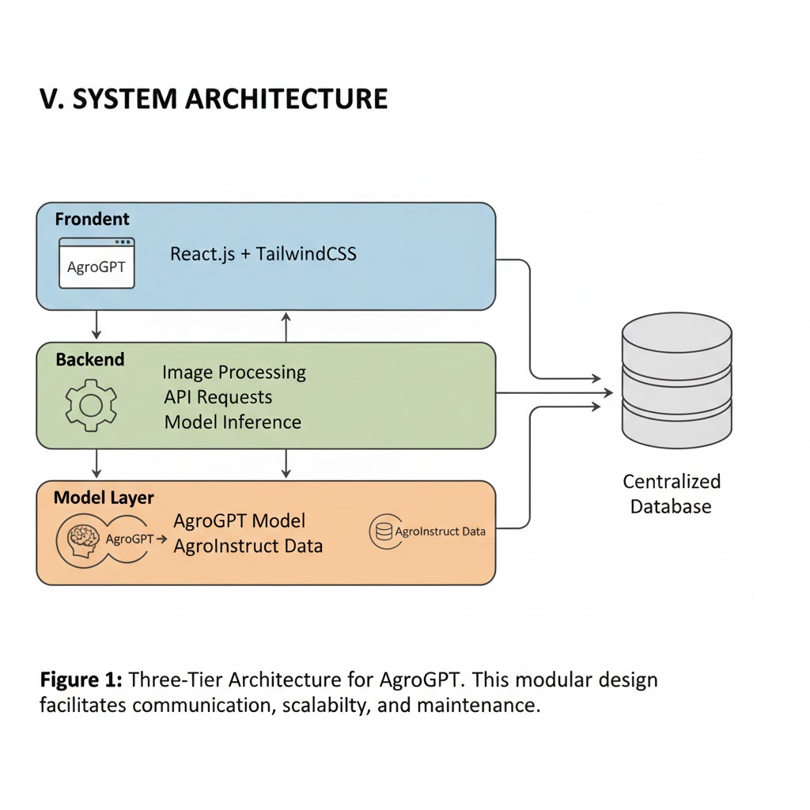
VI. MODEL WORKFLOW
The following figure illustrates the step-by-step workflow of the AgroGPT model, from dataset collection to deployment in the backend.
Each stage ensures that the model is accurately trained, validated, and integrated into the web-based architecture.
Certainly! Here's the model flow diagram.:
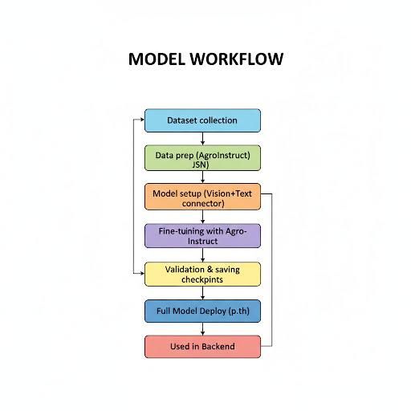
The AgroGPT model workflow consists of six stages: dataset collection, preprocessing, multimodal alignment, fine-tuning, evaluation, and deployment. Each stage ensures that the model effectively learns agricultural visual and textual patterns for accurate decision support.
Stage1: Dataset Collection
Agricultural datasets containing plant disease, weed, pest, and fruit images are collected from publicly available sources and annotated with descriptive captions.
Stage2:Preprocessing
Images are resized, normalized, and paired with expert-generated text instructions. Text data is tokenized and aligned with corresponding image embeddings.
Stage3:FeatureExtraction
The visual encoder extracts features from images while the language encoder processes text prompts. Both representations are fused through a projection layer to form a unified multimodal embedding.
Stage4:FineTuning
The AgroInstruct dataset (70,000 expert-tuned instruction–response pairs) is used to fine-tune AgroGPT, enhancing its ability to perform context-aware reasoning.
Stage5:Evaluation
The model is tested on custom evaluation benchmarks (AgroEvals) covering disease detection, pest identification, and yield reasoning. Accuracy and reasoning quality are measured through F1 and BLEU scores.
Stage6:Deployment
The trained model is deployed to the backend server, integrated with the user-facing web application. Farmers and researchers access it for real-time predictions.
FRONTEND LAYER
The frontend is the user-facing interface that enables farmers and researchers to interact with the AgroGPT model. Farmers log in using their phone number for quick access, while researchers use authenticated credentials. Users can upload images of crops or leaves, and the dashboard displays:
- Predicted yield (kg/ha)
- Detected disease or pest name
- Confidence score (%)
- Recommended control measures
This makes AgroGPT simple, accessible, and highly responsive for all users.
BACKEND LAYER
The backend, developed using Flask/Django, manages the system’s logic and communication with the Vision-Language Model.
Its major functions include:
- Validating user inputs and uploaded images.
- Preprocessing and converting data into model-readable format.
- Sending data to the AgroGPT inference module for predictions.
- Returning results and storing them in the central database.
- Managing user authentication and role-based access control.
The backend ensures smooth communication between the frontend, model, and database through RESTful APIs.
MODEL TIER
The Model Tier hosts the AgroGPT Vision-Language Model (VLM) — an advanced architecture that combines image and text understanding.
It comprises three key components:
- Visual Encoder: Extracts high-level features from agricultural images.
- Projection Layer: Converts visual embeddings into language tokens.
- Large Language Model (LLM): Processes textual instructions and generates intelligent agricultural insights.
AgroGPT’s expert-tuning pipeline allows it to interpret multimodal agricultural data, enabling precision in plant disease diagnosis, pest detection, and yield prediction.
DATABASE LAYER
The Database Layer stores and manages all system data securely using MySQL/MongoDB.
It contains tables for:
- User credentials and access logs
- Uploaded agricultural images
- Model predictions and confidence scores
- Historical records for model improvement
This structure supports data integrity, scalability, and reliability, ensuring both farmers and researchers can retrieve accurate predictions anytime.
A.Abbreviations and Acronyms
The following abbreviations and acronyms are used throughout this paper
AI - Artificial Intelligence
ML - Machine Learning
VLM - Vision-Language Model
LLM - Large Language Model
CLIP - Contrastive Language-Image Pretraining
API - Application Programming Interface
UI - User Interface
DB - Database
CSV - Comma separated Values
AgroGPT - Agricultural Vision-Language Model
B.Units
All measurements in this project use standard SI (MKS) units for consistency:
- Soil moisture: percentage (%)
- Crop yield: kilograms per hectare (kg/ha)
- Land area: hectares (ha)
Non-SI values are automatically converted before preprocessing to maintain uniformity.
C.Equations
In AgroGPT, each image–text pair $(I,T)$is processed through a multimodal fusion function:
$$Z=f(E_{v}(I),E_{t}(T))$$
Where,
$E_{v}$= Visual Encoder,
$E_{t}$= Text Encoder,
$f$= Fusion Layer combining both features.
Final output probabilities are computed as:
$$Y=\text{Softmax}(W⋅Z+b)$$
Here, $W,b$are learnable parameters, and $Y$represents predicted class probabilities (e.g., Healthy, Diseased, Pest-Affected).
Loss function used during training:
$$L=-\sum_{i=1}^{n}{}y_{i}log⁡(\hat{y_{i}})$$D.Some Common Mistakes
To ensure accuracy and reproducibility, the following errors were avoided:
- Maintaining consistent definitions for AI and agricultural terms.
- Using SI units in all measurements.
- Ensuring dataset balance (no missing or duplicate samples).
- Applying clear notation for equations and parameters.
- Following IEEE formatting standards for headings and labels.
VII. SYSTEM OVERVIEW AND IMPLEMENTATION
Authors and Affiliations:
This project titled “AgroGPT: Efficient Agricultural Vision-Language Model with Expert Tuning” was developed by Group G606 under the guidance of Mr. T. Vijaynag.
The system integrates Vision-Language AI for precision farming applications, enabling crop disease detection, pest identification, and yield prediction.
System Components:
- Frontend: React.js + TailwindCSS for a responsive farmer interface.
- Backend: Flask/Django for data management and model API integration.
- Model: Fine-tuned Vision-Language Model (AgroGPT).
- Database: MySQL/MongoDB for data persistence.

TABLE: COMPARISON BETWEEN EXISTING SYSTEMS AND AGROGPT
Existing Machine Learning Models | Proposed AgroGPT  Framework
 | Combines image and text understanding(multimodal)
  Works only with tabular or text data
Requires manual feature engineering | Learn features automatically using deep encoders
Limited or single data type | Integrates multimodal datasets for better context
No conversational capability | Supports interactive Q&A with users
Low accuracy for complex image-text relations | Achieves higher precision with expert-tuned VLM
Poor generalization on unseen data | Fine-tuned on AgroInstruct for domain robustness

VIII. CONCLUSION
The AgroGPT model provides a modern and intelligent solution for agriculture through the integration of Vision-Language Learning.
It combines image understanding and natural language reasoning to deliver context-aware insights for farmers and researchers.
By addressing challenges like data scarcity and domain gaps, AgroGPT significantly improves disease identification, pest detection, and yield prediction.
This system marks a step toward AI-driven sustainable farming, promoting efficiency, accuracy, and environmental awareness.

IX.ACKNOWLEDGMENT
The authors extend heartfelt gratitude to Mr. T. Vijaynag, Assistant Professor, Department of Computer Science and Engineering, for his constant support, guidance, and encouragement throughout this project. The team also thanks the Keshav Memorial College of Engineering for providing technical resources and research support.
Special appreciation goes to all team members for their collaborative effort in successfully completing the AgroGPT project.
X.REFERENCES
- Liu, H. et al., "Visual Instruction Tuning," arXiv preprint arXiv:2304.08485, 2023.
- Radford, A. et al., "Learning Transferable Visual Models From Natural Language Supervision," arXiv preprint arXiv:2103.00020, 2021.
- Zheng, S. et al., "A Survey of Large Multimodal Models," IEEE Access, 2023.
- Wu, J. et al., "Multimodal Machine Learning for Agricultural Image Understanding," IEEE Access, vol. 10, pp. 34123–34135, 2022.
- Doshi, R. et al., "AI in Agriculture: Applications and Challenges," Computers and Electronics in Agriculture, 2022.

